Cross Durham Social Relay: Sunday July 5 (9am – afternoon)
(Appx 30miles)
From here (Durham border) to here (Witton Gilbert)
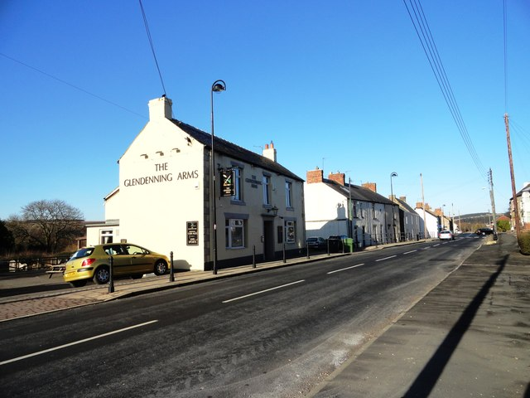
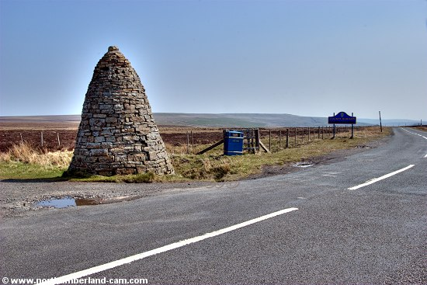
We’re planning a social relay in stages from the border between Durham and Northumberland as far as Witton Gilbert where we will celebrate with a bit of a get together at Liz’s place.
If you’d like to join in and run one of the legs or part of one, please get in contact with Gary by email/facebook or on Club night If anyone is up to running the whole way that can be done! Below is some information but if you’ve any questions get in touch. This is all pretty informal, we depend on lifts being arranged between people to help support and to get there. Also this year we wondered if anyone would like to volunteer to support all the way on a bike (cycle track all the route). Again please get in touch.
We aim to raise some money for an Alzheimer’s Charity by this event. We’ll hopefully produce a DVD of the day for sale with the proceeds to charity. Also there’ll be a raffle at the social at the end.
Find the map and profile of the whole route here

http://gb.mapometer.com/running/route_4103297.html
Stage 1 (start running at 9am) Appx 10 miles
Find the route/profile and start and finish locations for Stage 1 here

http://gb.mapometer.com/running/route_4103360.html
Start at the Durham Northumberland border just to the east of Allenheads. Run as far as the Parkhead Station cafe. This section starts with a gentle downhill bit of road to Rookhope then goes steep up on to the moors for the next 5 miles to Parkhead. If the weather is miserable this could be a tough section and appropriate gear needed. Good path all the way. Expected this group would run appx 9min mile or faster.
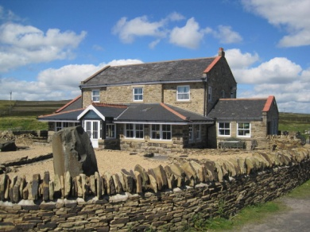 Parkhead cafe (end of stage)

Stage 2 (Appx start time 11am) 11-12 miles appx.
Find the route and start finish locations for Stage 2

http://gb.mapometer.com/running/route_4103412.html
Start at the Parkhead Cafe and run as far as the layby which is just across the road from the Hurbuck cottages. The cottages are near Knitsley just west of Lanchester (check map). Good cycle track all the way but the first 3 miles lies across high moorland so appropriate gear needed if weather miserable. No significant hills. Generally downhill all the way. Expected pace appx 9-10 min mile.
Stage 3 (Appx start time 1pm) 8 miles appx
From the layby near Hurbuck cottages to Witton Gilbert. Good cycle path. Generally flat or downhill.
If anyone would like to join the group at Malton picnic site just one km east of Lanchester for the last 4 miles when the group will be running at a slower very easy relaxed pace then please do so. It’d be great if we could get a decent number coming along to run together. If you’ve run one of the earlier stages then join in again for the last few miles.
Find the route/profile and start finish locations for Stage 3 as far as Malton Picnic Site here

http://gb.mapometer.com/running/route_4103421.html
Find the route/profile and start finish locations from Malton Picnic Site to Witton Gilbert here

http://gb.mapometer.com/running/route_4103428.html
More details to follow closer to the day but if you’re interested please get in touch so we can sort out who is running the different legs and to give people time to sort out some transport arrangements.
Many thanks.

